WH1424
Thermostat and Humidity Controller
Product Manual

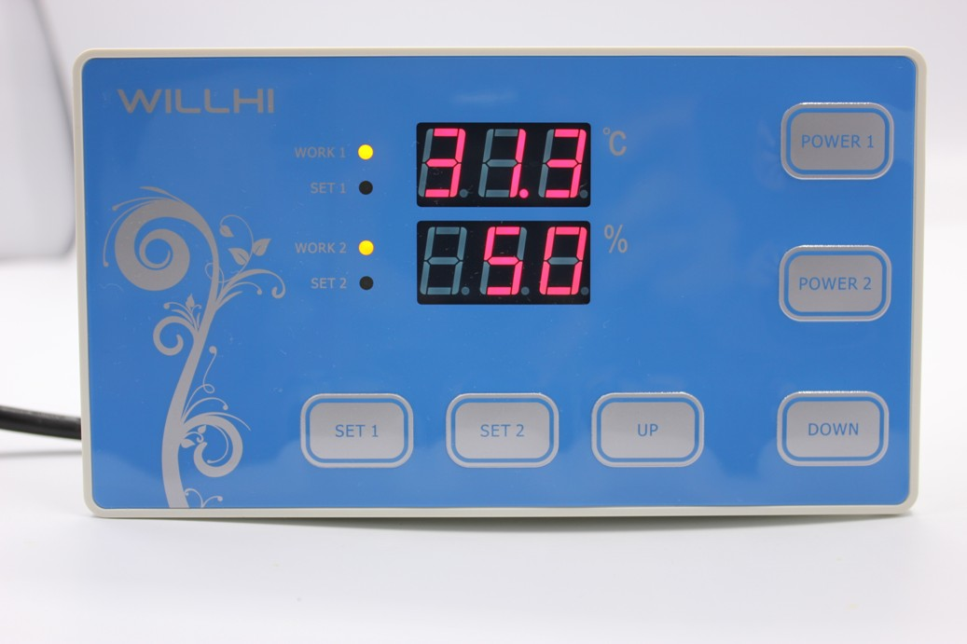

Shenzhen Willhi Electronics Co., Ltd.
Tel :0755 -29539385 Fax :86-0755 -2953 9395
Technical support: Engineer Tian

◆ Installation opening size:

Thermostat Controlle
◆LED Status Description:
The WORK light is used as working indicator lights, flashing is to indicate the delay of cooling or heating, if the LED is always on, it indicates it is on the status of cooling or heating .
The SET light is used as setting indicator lights, if the LED is always on, it indicates it is on the status of setting.
◆Turn on or off the thermostat:
When it is wired up, the state of being acquiescent is power on.
Press “POWER1” key to switch on and off, press the “POWER 1” key once on the power-off state to turn it on. On the power-on state, press the “POWER 1” key and hold on for three seconds, then it will be off.
◆temperature control setting：
In the Standby mode, press the “SET1” key once to enter the temperature control setting, press “UP” or “DOWN” button to adjust, press “UP” or “DOWN” button and hold on for three seconds to enter the fast adjusting mode, press the “SET1” key again and back to the standby mode.

◆system menu settings：
Press “SET1” and “UP”key and hold on for 3 seconds to enter the Thermostat controlled- parameters setting, press the “UP” or “DOWN” key to select the adjustment menu, press “SET1” key once to enter the appropriate parameter settings, press “UP” or “DOWN” to adjust the parameters needed to be modified. After being adjusted, press the “POWER1” key to exit, or exit as the system delay for 5 seconds.

◆ Menu code statement:
Symbol | Details | Remark
HC | Heating / cooling | H= Heating C= cooling
D | Hysteresis
LS | The minimum set limit
HS | The maximum set limit
CA | Temperature calibration
PT | Delay time | Minutes
AH | High temperature alarm settings
AL | low temperature alarm settings

◆Cooling, heating function:
Cooling Mode: When the measured temperature is higher than or equal to the set value + hysteresis, the relay picks up to start the output; When the measured temperature below the set value, the relay off and close the output.
Heating mode: When the measured temperature is higher than or equal to the set value, the relay off, turn off the output; When the measured temperature below the set value - hysteresis, the relay picks up to start the output.

Example for Setting: If it is set to heating mode, set the temperature to 25 degrees, hysteresis is set to 5, then when the measured temperature is higher than or equal to 25 degrees, the relay is off, close the output. When the temperature is below 20 degrees, pick up the relay again, to start the output.
Example for Setting: If it is set to cooling mode, set the temperature to 25 degrees, hysteresis is set to 5, then when the measured temperature is below 25 degrees, the relay is off, close the output. When the temperature is higher than or equal to 30 degrees, pick up the relay again, to start the output.
◆ Cooling, heating mode setting:
Press “SET1” and “UP”key and hold on for 3 seconds to enter the menu display, the screen appears "HC" code, press the "SET1" key to display the working mode, press the "UP" or "DOWN" to adjust the display, C means cooling mode; H means heating mode.
◆ Hysteresis function:
Hysteresis setting limits the maximum interval between the opening and stopping.
◆ Hysteresis settings:
Press “SET1” and “UP”key and hold on for 3 seconds to enter the menu display, with "UP" or "DOWN" key adjusted to the screen, appearing "D" code, press the "SET1" key to display the hysteresis set value, press "UP "Or "DOWN" key to adjust the parameters.
◆ Temperature calibration function:
When there is deviation between the measuring temperature and standard temperature, use the temperature calibration function, make the machine measurements value consistent with the standard temperature, the after calibration temperature= the before calibration temperature + calibration value (calibration value can be positive number, negative number, and 0) .
◆ Temperature calibration settings:
Press “SET1” and “UP”key and hold on for 3 seconds to enter the menu display, with "UP" or "DOWN" key adjusted to the screen, appearing "CA" code, press the "SET1" key to display the temperature calibration settings, press "UP "Or"DOWN"key to adjust the parameters.
For example: When we measure the probe temperature was 25 degrees, it displays 25 degrees as the CA is 0, it displays 26 degrees as the CA is 1, it displays 24 degrees as the CA is -1. This function is generally applied when the probe can not measure directly the measured object. For example, we place the probe at the outside of a cup to measure its water temperature, we need to adjust the CA parameters because of the heat loss of the cup, so that the display temperature can be in accordance with the one of the cup.

◆ Delay Protection Function:
In the cooling mode, the first power on, when the measured value above the set value + hysteresis value, the machine will not immediately start cooling, it needs to set the delay time, then the machine can run to start cooling; once the interval between two cooling is larger than the delay time, the machine immediately starts cooling, once the interval between two cooling is less than the delay time, the machine must run the remaining delay time to start cooling. The delay time is started to calculate from stopping the machine. The delay time of heating mode is as same as the cooling mode.
Note: It is recommended that only the device that use compressor cooling can use the delay start function, the user who don't need delay start function please set this parameter to 0.
◆ Delay Protection Setting:
Press “SET1” and “UP”key and hold on for 3 seconds to enter the menu display, with "UP" or "DOWN" key adjusted to the screen, appearing "PT" code, press the "SET1" key to display the delay setting value, then press the "UP "or "DOWN"key to adjust the parameters.
◆ Upper and lower limit functions:
The setting of HS and LS limit the set range of control temperature point , for example: HS is set to +15, LS is set to -10, the control temperature can only be adjusted between -10 and +15, when the control temperature to -10 then press "DOWN" key, the display will remain on the status of -10 and not decrease; when the control temperature to +15 then press "UP" key, the display will on the status of 15 and not increase. If the set point outside this range, it needs to firstly change the value of HS and LS, then it can be achieved.
◆Upper and lower limit settings:
Press “SET1” and “UP”key and hold on for 3 seconds to enter the menu display, with "UP" or "DOWN" key adjusted to the screen, appearing "HS" or "LS" code, press the "SET" key to display the upper or lower limit set value, Then press "UP" or "DOWN" key to adjust the parameters. HS means upper limit. LS means lower limit.

◆High temperature alarm:
If the measured temperature≥ set temperature + AH alarm output relay. Thermostat alarm will sound, the display alternately shows H and the current temperature. Alarm, press any key to stop the alarm and relay output.
◆ High temperature alarm settings:
Press “SET1” and “UP”key and hold on for 3 seconds to enter the menu display, with "UP" or "DOWN" button transferred to the screen appears "AH" code, press the "SET1" key to display the high-temperature alarm settings, press "UP "or" DOWN "key to adjust the parameters
◆ Low temperature alarm function:
If the measured temperature ＜set temperature-AL when the alarm output relay. Thermostat alarm will sound, the display alternately shows L and the current temperature. Alarm, press any key to stop the alarm and relay output.
◆ low temperature alarm settings:
Press “SET1” and “UP”key and hold on for 3 seconds to enter the menu display, with "UP" or "DOWN" button transferred to the screen appears "AL" code, press the "SET1" key to display the low temperature alarm settings, press "UP "or" DOWN "key to adjust the parameters

⑥ Errors indications:
1) When the sensor disconnected, the screen displays EEE ,
2) When the sensor detects the temperature is below the lowest temperature that could be detected, the screen displays LLL.
3) When the sensor detects a temperature higher than the Maximum temperature that could be detected, the screen displays HHH.

Humidity Controller:
◆LED Status Description:
The WORK lights at the left side of the screen is used as working indicator lights, flashing is to indicate the delay of Humidification or Dehumidification
, if the LED is always on ,it indicates it is on the status of Humidification or Dehumidification .
The SET light at the left side of the screen lights is used as setting indicator lights, if the LED is always on ,it indicates it is on the status of setting.
◆Turn on or off the Humidity Controller:
When it is wired up, the state of being acquiescent is power on.
Press” POWER2” key to switch on and off, press the ” POWER2” key once on the power-off state to turn it on. On the power-on state, press the ” POWER2” key and hold on for three seconds, then it will be off.
◆Humidity control setting：
In the Standby mode, press the “SET2” key once to enter the Humidity control setting, press “UP” or “DOWN “button to adjust, press “UP” or “DOWN” button and hold on for three seconds to enter the fast adjusting mode, press the “SET2 “key again and back to the standby mode.

◆system menu settings：
Press “SET2” and “UP”key and hold on for 3 seconds to enter the controlled- parameters setting, press the “UP” or “DOWN” key to select the adjustment menu, press “SET2” key once to enter the appropriate parameter settings, press “UP” or “DOWN” to adjust the parameters needed to be modified. After being adjusted, press the “POWER2” key to exit, or exit as the system delay for 5 seconds.

◆ Menu code selection:
Symbol | Details | Setting range | Factory settings | Units
HC | Humidification, /Dehumidification | H/C | C | H= Humidification  C= Dehumidification
D | Hysteresis | 1%～25% | 5 | ℃
LS | The minimum set limit | 0%～100% | 0% | ℃
HS | The maximum set limit | 0%～100% | 100% | ℃
CA | Humidity calibration | -12%～+12% | 0 | ℃
PT | Delay time | 0～30 | 1 | Minutes

◆Humidification, Dehumidification function:
Dehumidification Mode: When the measured Humidity is higher than or equal to the set value + hysteresis, the relay picks up to start the output; When the measured Humidity below the set value, the relay off and close the output.
Humidification mode: When the measured Humidity is higher than or equal to the set value, the relay off, turn off the output; When the measured Humidity below the set value - hysteresis, the relay picks up to start the output.
Example for Setting: If it is set to Humidification mode, set the Humidity to 75%, hysteresis is set to 5, then when the measured Humidity is higher than or equal to 75%, the relay is off, close the output. When the temperature is below 70%, pick up the relay again, to start the output.
Example for Setting: If it is set to Dehumidification mode, set the Humidity to 75%, hysteresis is set to 5, then when the measured Humidity is below 75%, the relay is off, close the output. When the Humidity is higher than or equal to 80%, pick up the relay again, to start the output.
◆Humidification, Dehumidification mode setting:
Press "SET2" and “UP”key and hold more than 3 seconds to enter the menu display, the screen appears "HC" code, press the "SET2" key to display the working mode, press the "UP" or "DOWN" to adjust the display, C means Dehumidification mode; H means Humidification mode.
◆ Hysteresis function:
Hysteresis setting limits the maximum interval between the opening and stopping, this machine minimum interval between the opening and stopping is 1 %, the maximum is 25 %.
◆ Hysteresis settings:
Press "SET2" and “UP” key and hold more than 3 seconds to enter the menu display, with "UP" or "DOWN" key adjusted to the screen, appearing "D" code, press the "SET2" key to display the hysteresis set value, press "UP "Or"DOWN"key to adjust the parameters.
◆Humidity calibration funtion:
When there is deviation between the measuring Humidity and standard Humidity, use the Humidity calibration function, make the machine measurements value consistent with the standard Humidity, the after calibration Humidity = the before calibration Humidity + calibration value (calibration value can be positive number, negative number, and 0) .
◆Humidity calibration settings:
Press "SET2" and “UP” key and hold more than 3 seconds to enter the menu display, with "UP" or "DOWN" key adjusted to the screen, appearing "CA" code, press the "SET2" key to display the temperature calibration settings, press "UP "Or"DOWN"key to adjust the parameters.

For example: When we measure the probe Humidity was 75 %,it displays 75% as the CA is 0, it displays 76% as the CA is 1, it displays 74 % as the CA is -1. This function is generally applied when the probe can not measure directly the measured object.
◆ Delay Protection Funtion:
Set the device boot twice the shortest time interval
◆ Delay Protection Setting:
Press "SET2" and “UP” key and hold more than 3 seconds to enter the menu display, with "UP" or "DOWN" key adjusted to the screen, appearing "PT" code, press the "SET2" key to display the delay setting value, then press the "UP "or "DOWN"key to adjust the parameters.

◆ Upper and lower limit functions:
The setting of HS and LS limit the set range of control Humidity point , for example: HS is set to 75, LS is set to 50, the control Humidity can only be adjusted between 50 and 75, when the control Humidity to 50 then press "DOWN" key, the display will remain on the status of 50 and not decrease; when the control temperature to 75 then press "UP" key, the display will on the status of 75 and not incease. If the set point outside this range, it needs to firstly change the value of HS and LS, then it can be achieved.
◆Upper and lower limit settings:
Press "SET2" and “UP” key and hold more than 3 seconds to enter the menu display, with "UP" or "DOWN" key adjusted to the screen, appearing "HS" or "LS" code, press the "SET2" key to display the upper or lower limit set value, Then press "UP" or "DOWN" key to adjust the parameters. HS means upper limit. LS means lower limit.

◆High Humidity alarm:
If the measured Humidity≥ set Humidity + AH alarm output relay. Humidity alarm will sound, the display alternately shows H and the current Humidity. Alarm, press any key to stop the alarm and relay output.
◆ High Humidity alarm settings:
Press “SET2” and “UP”key and hold on for 3 seconds to enter the menu display, with "UP" or "DOWN" button transferred to the screen appears "AH" code, press the "SET2" key to display the high- Humidity alarm settings, press "UP "or" DOWN "key to adjust the parameters
◆ Low Humidity alarm function:
If the measured Humidity ＜set Humidity -AL when the alarm output relay. Humidity alarm will sound, the display alternately shows L and the current temperature. Alarm, press any key to stop the alarm and relay output.
◆ low temperature alarm settings:
Press “SET2” and “UP”key and hold on for 3 seconds to enter the menu display, with "UP" or "DOWN" button transferred to the screen appears "AL" code, press the "SET2" key to display the low Humidity alarm settings, press "UP "or" DOWN "key to adjust the parameters

⑥ fault tips:
1)When the sensor disconnected, the screen displays EEE and close the output

⑦ Caution for using:
◆ Please connect the correct operating voltage, the machine normally works under the standard input voltage within range of ± 10%.
◆ The load power should not exceed the maximum thermostat control power, when exceeding please connect external AC contactor.
◆ Please connect the power load correctly and the sensor, or it will damage the thermostat, when connect the wrong line .
◆ Please do not put the sensor lines and power lines in parallel, power line noise affects the accuracy of the measurement.

